# CS 255 System Design

## UML Diagrams

### UML Use Case Diagram

*This diagram illustrates the process from the user login to viewing available times, selecting a preferred slot, and confirming the booking. It emphasizes decision points like availability checks and user confirmations to ensure the process is intuitive and efficient.*

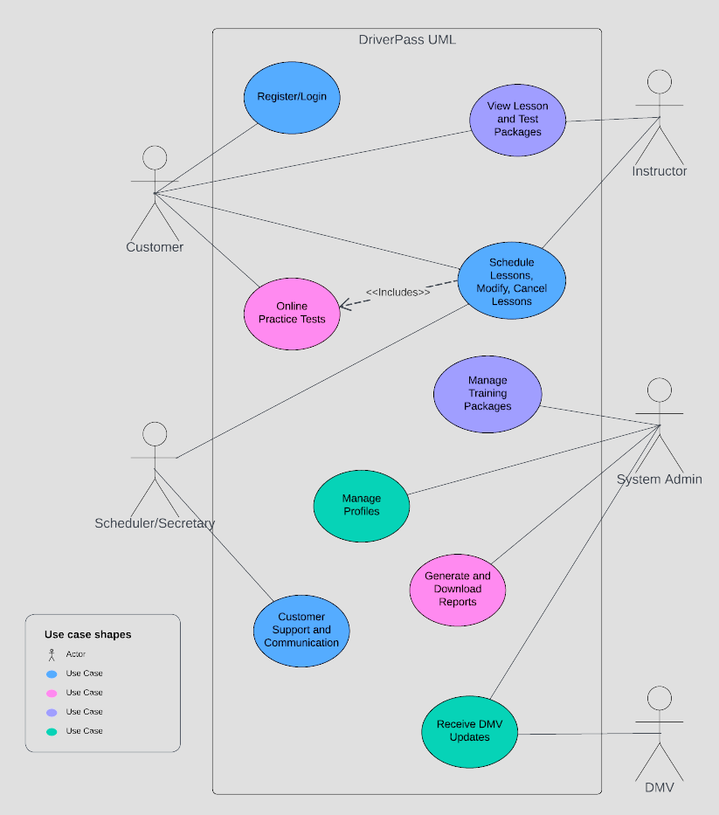

### UML Activity Diagrams

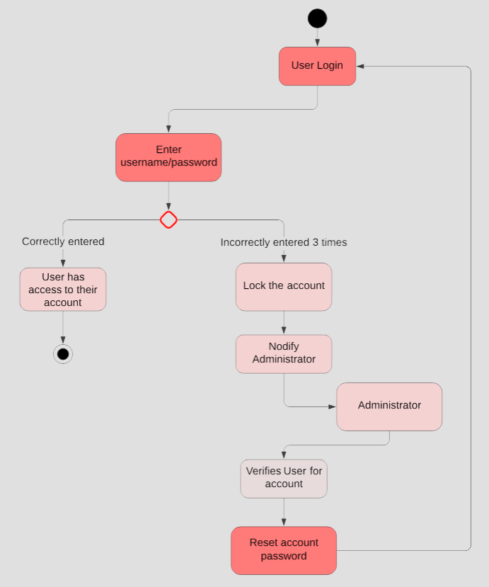

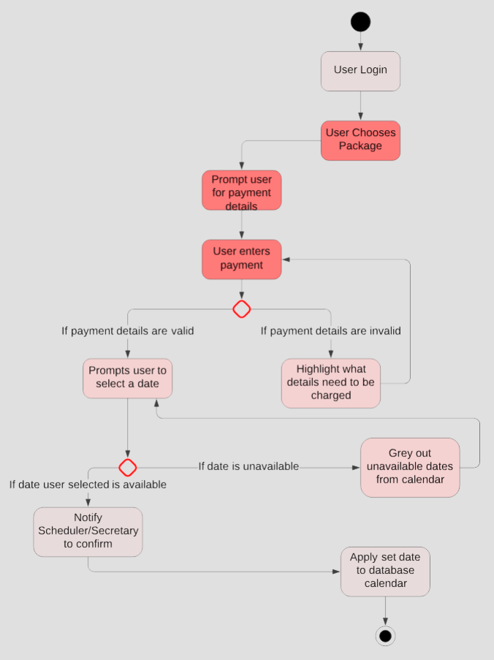

UML Sequence Diagram

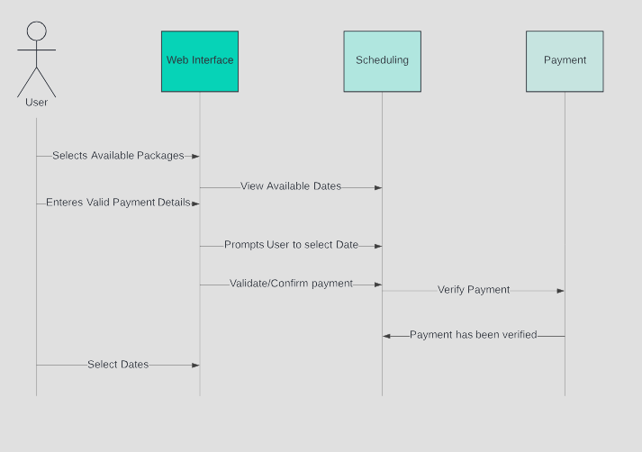

### UML Class Diagram

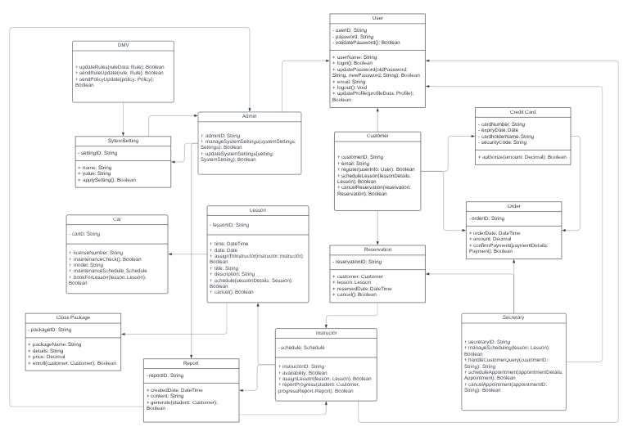

## Technical Requirements

*(Along with closing notes)*

*As we venture into the development phase of the DriverPass system, I want to outline the technical foundation that will bring our design to life. It's like building a house; our diagrams are the blueprints, and now we're discussing the bricks, mortar, and tools we need to construct it.*

***Hardware Requirements:***

* ***Servers****: We'll require robust servers to manage the anticipated traffic and data processing. Think of these as the powerhouse of our operations, capable of handling the hustle and bustle of our digital traffic.*
* ***Workstations****: For our team, high-performance workstations will be essential for developing and maintaining the system. These are the desks where our creative and technical magic happens.*
* ***Networking Equipment****: Reliable routers and switches will form the veins and arteries of our network, ensuring data flows seamlessly and securely.*

***Software Requirements:***

* ***Operating System****: We'll utilize a server OS known for stability and security. Imagine this as the stable ground upon which our system will stand.*
* ***Database Management System****: A scalable DBMS will be our system's memory, carefully organizing and recalling data as needed.*
* ***Web Server Software****: The platform that serves our web pages to users needs to be both nimble and resilient.*
* ***Development Frameworks****: We'll harness the latest frameworks that enable us to build flexible and maintainable code – the structural integrity of our system.*

***Tools:***

* ***Version Control System****: To manage our code precisely, we'll use a system that tracks every change, ensuring that we can always backtrack to a safe point, like a detailed construction log.*
* ***Integrated Development Environment (IDE)****: Our developers will use sophisticated IDEs to write, test, and debug code, like an architect's drafting table equipped with the best tools.*
* ***Lucidchart****: We'll continue to use Lucidchart for ongoing design modifications and visual documentation. It's our digital sketch pad, where we visualize complex concepts clearly.*

***Infrastructure:***

* ***Cloud Services****: We'll leverage cloud services to ensure scalability and reliability. It's like having a plot of land in every city, accessible from anywhere.*
* ***Backup Solutions****: Regular backups will be our safety nets, protecting us from data loss.*
* ***Disaster Recovery Plans****: In the unlikely event of a system failure, we'll have a clearly defined recovery plan – our emergency exits and protocols to swiftly restore order.*

*As we proceed, we aim to equip DriverPass with the most reliable, efficient, and secure technical environment. We're building not just for today but for the many roads your company will travel down in the future.*

*Thank you for entrusting us with this task, and I look forward to our journey ahead.*